Logbook 2 (for offline log preparation)
Name: | Yvette Lee EnQi
Week Date: | Part A -Meeting 2 of 8
(The above information is for you to keep track of which week this log is applicable for. This information is not required in the online logbook as the system will find your name, your supervisor’s name, and take the submission date, automatically. You must submit the online log in the relevant week. Logs cannot be backdated to missed weeks.)

Meeting date:  (please note if no meeting is planned this week) | 09/06/2026
Work Undertaken this week:  (No more than 4000 characters, including spaces) | Following supervisor feedback from Meeting 1, I rewrote all four literature reviews using the 5C framework (Cite, Comment, Critic, Compare, Connect). Each review now explicitly identifies limitations of the existing project, compares similarities with my own work, and explains how my project addresses the identified gap. The revised reviews cover Bawden et al. (2017), TerraSentia, Thorvald II, and Yang et al. (2024).  Singapore Farm & Greenhouse Environment Research  - Singapore farming is dominated by high-density vertical farms and rooftop greenhouses due to extreme land scarcity (~720 hectares total).  - Primary crops are Asian leafy greens (chye sim, xiao bai cai, kai lan), which have smaller, denser canopies than Western lettuce.  - Vertical farm gutters: 0.1 m wide, 0.15 m plant spacing, racks up to 20 levels high.  - Outdoor greenhouse soil beds: ~0.3 m row spacing.  - Derived robot targets: width < 20 cm, weight < 2 kg (protects gutters/soil), camera focal distance ~15 cm, cost sub-$1,500.  Analysis of New And Existing Robots  - Naio Oz: Lightweight, GNSS row-following; but designed for weeding intervention, not health monitoring.  - TerraSentia: ~10 kg under-canopy phenotyping robot; validates small camera-only concept but lacks onboard AI and is too heavy for elevated vertical racks.  - Thorvald II: Large, modular, LiDAR+GNSS; robust but expensive and over-engineered for simple monitoring.  - Husky A300: 100 kg research platform; far too heavy and costly.  - Fendt Xaver: Swarm of small seeding robots using GNSS/cloud; relevant for distributed monitoring but proprietary and not health focused.  - Small Robot Company: AI-driven per-plant weeding; strong vision pipeline but mechanically complex and intervention-oriented.  - Agrointelli Robotti: Diesel-electric multi-implement platform; too large and combustion-based for indoor farms.  Refined Design Targets  - Chassis width < 19 cm, weight < 2 kg.  - Downward-facing RGB camera at ~15 cm focal distance.  - Dual-mode navigation: GNSS + IMU + encoders (outdoor); encoder + IMU (indoor GNSS-denied).  - Ultrasonic-only obstacle avoidance (LiDAR-free to meet sub-$1,500 budget).  Base Platform Decision  - Undecided, but leaning toward a custom 3D-printed chassis.  - Pros of custom: Optimised camera mount position, battery placement, and structural rigidity specifically for downward leaf imaging; full mechanical flexibility; no dependency on pre-built platform constraints.  - Cons of custom: Higher initial design and fabrication risk; tighter timeline.  - TurtleBot3 Burger: Remains a fallback option (17.8 cm wide, ~1 kg, strong ROS2 Humble support) if the custom build becomes unmanageable.
Problems encountered:  (No more than 4000 characters, including spaces) | - Custom chassis design risk: building a 3D-printed robot from scratch introduces mechanical uncertainty (frame rigidity, wheel alignment, weight distribution) that the TurtleBot3 avoids. I need to validate the design through CAD simulation or a small proof-of-concept print before committing.  - Component payload and balance: with a custom chassis, I must design the battery, Raspberry Pi, camera, and sensor placement simultaneously to keep the centre of gravity low and prevent tipping during row traversal.  - Camera mount design: a downward-facing camera for gutter-level imaging requires a rigid mast or angled bracket with vibration damping. I need to confirm 3D printer availability and whether PLA or PETG should be used for outdoor humidity resistance.  - Indoor versus outdoor scope uncertainty: the project brief specifies GPS and wheel odometry, but Singapore vertical farms are indoor and GNSS-denied. I need supervisor clarification on whether the undergraduate scope is limited to outdoor or greenhouse simulation, or if indoor dead-reckoning should also be included.  - Dataset crop mismatch: public datasets like PlantVillage focus on Western crops. Asian leafy greens have different leaf morphology and disease symptoms. I need to confirm whether the lab has access to potted Asian greens or if I should use lettuce or basil as a proxy crop.  - Manufacturing tolerance and repeatability: 3D-printed parts (especially in PLA) have lower rigidity and dimensional accuracy than injection-moulded or machined components. Layer adhesion and warping could affect wheel alignment and camera pointing stability. Need to test print critical parts (motor mounts, camera bracket) before full assembly.
Tasks agreed for upcoming week:  (No more than 4000 characters, including spaces) | - Sketch initial custom chassis design in Fusion 360 or Tinkercad, including wheel placement, battery tray, and camera mast position. Target width under 20 cm and weight under 2 kg.  - Weigh all candidate components (Raspberry Pi 5, Coral TPU, Pi Camera Module 3, 11.1V LiPo battery, DC motors, motor driver, ultrasonic sensors). Record in spreadsheet and calculate total payload + centre of gravity estimate.  - Meet with supervisor to confirm: indoor versus outdoor validation scope; whether IMU integration is expected in the undergraduate project or deferred to postgraduate work; and feedback on the custom chassis versus TurtleBot3 decision.  - Draft the Project Outline document incorporating the custom chassis concept, refined specifications from Singapore farm research, and updated literature reviews.  - Continue reading on ROS2 navigation packages (nav2, robot_localization) and motor control interfaces for custom differential-drive robots.  - Do not procure any parts until the supervisor has approved the project outline and scope.
Figures:  (Upload image files in the online Log Form, but feel free to keep notes here about which images you intend to upload. Use “Figure Caption” information as the filenames, e.g., “Figure 1 – A screenshot of the initial constrained Sketch in CATIA.jpg”) | Sketch an artistic view of your project  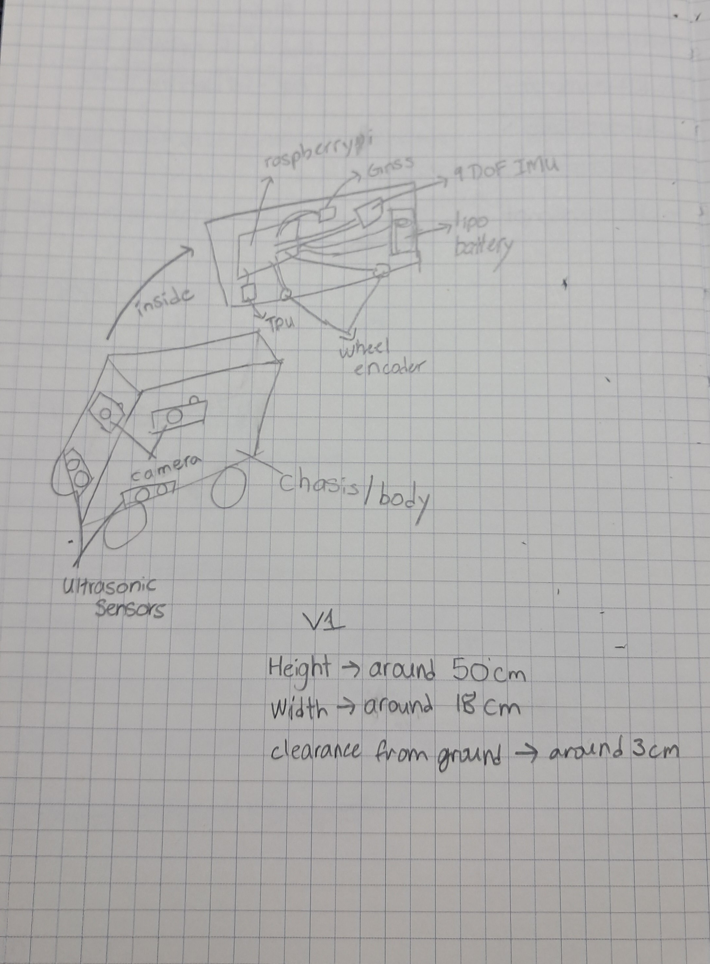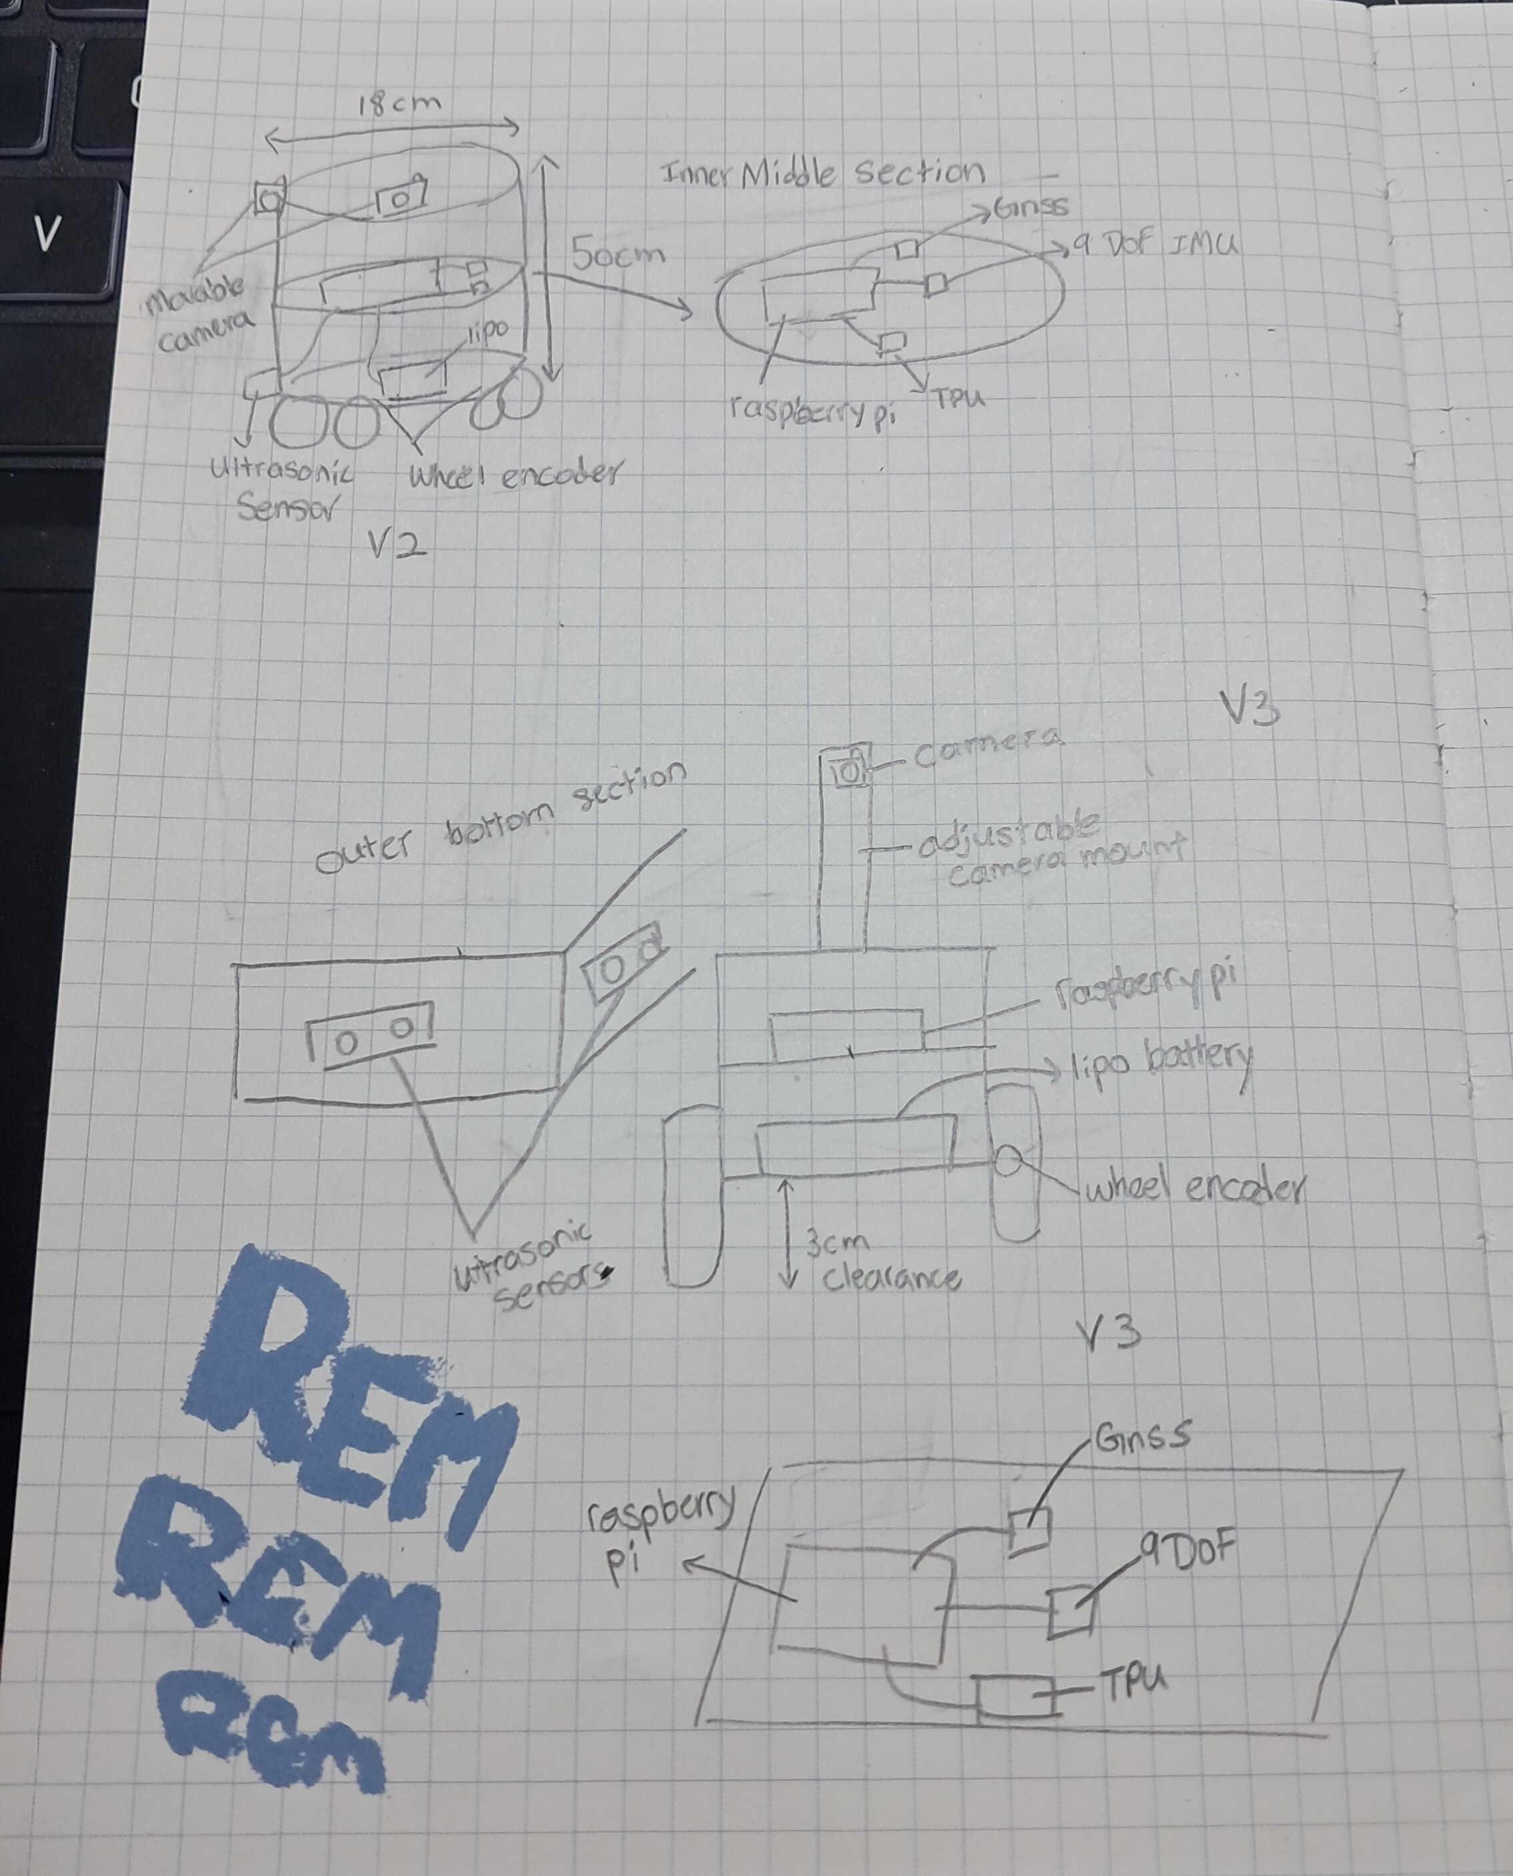  There are 3 different concept designs now  - Key software codes/modules that need to be developed (Remains the same as of now)  Block diagram of your system  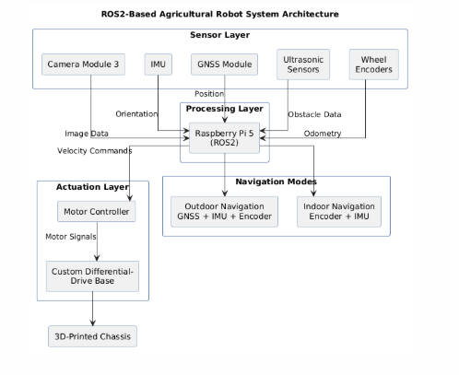  Robot comparison table  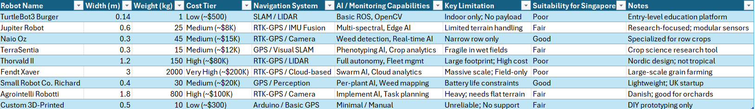  Farm layout  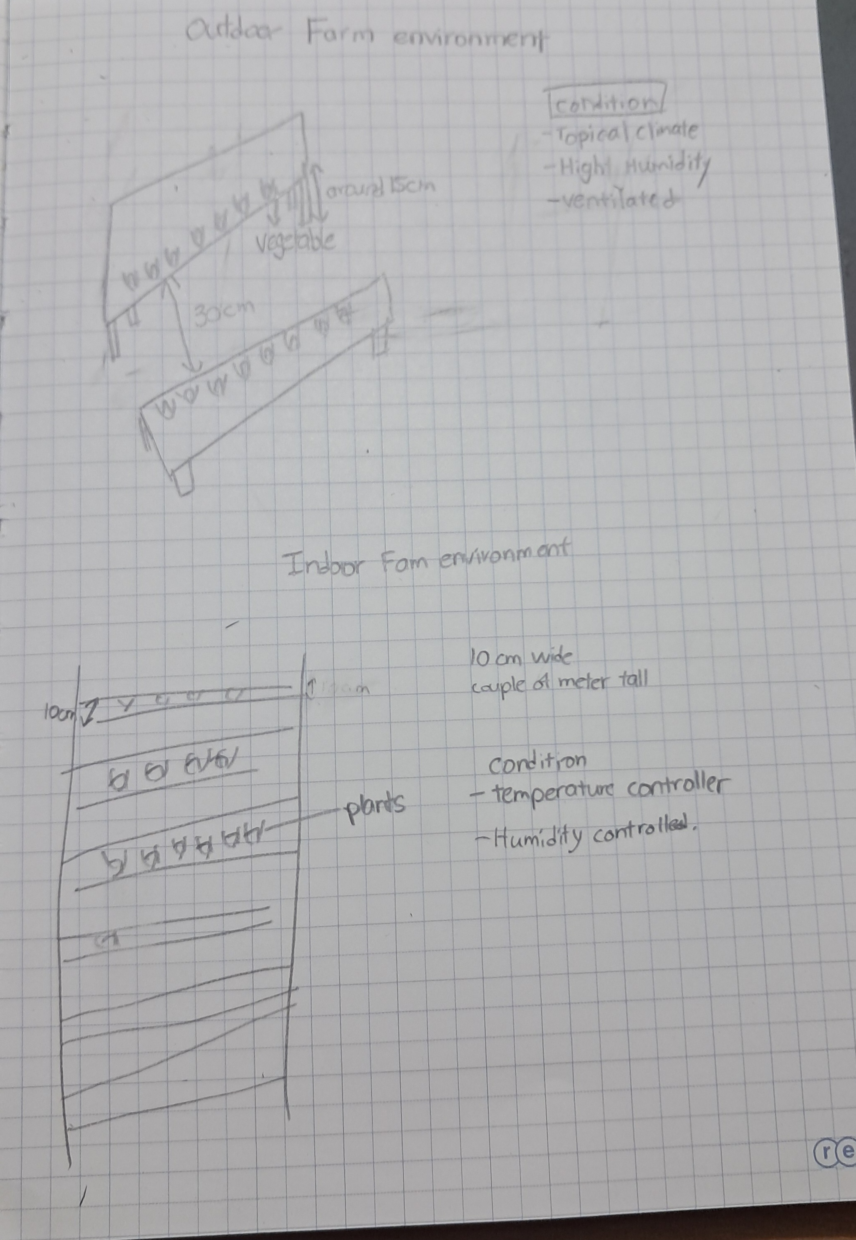  Quality and Regulatory issued to be addressed  Electrical Safety: System might operates at 11.1V LiPo (below 30V threshold). No mains voltage exposure. Low risk.  Mechanical Safety: Robot mass < 5 kg, maximum speed < 0.5 m/s. No rotating blades or pinch points.  Mechanical Safety (updated): Custom 3D-printed chassis must be tested for structural integrity under load. Sharp edges from printed parts to be sanded/fillet added. Wheel guards to prevent entanglement. No risk assessment required beyond standard lab induction.  Environmental: Outdoor operation limited to dry conditions; IP rating not required for lab/greenhouse phase. No hazardous fluids or chemicals.  Data/Ethics: No human subjects. If photographing real farm fields, ensure owners’ consent. Plant images are non-sensitive, but GPS-tagged data should be stored securely if representing a real commercial farm.  Standards: No mandatory CE/ISO compliance for prototype stage, but design will follow ISO/TS 15066 collaborative robot principles for force/speed limits as best practice.
  Module | Language | Platform / Framework | Description
  nav_waypoint_node | Python | ROS2 | Subscribes to GNSS/IMU/encoder topics, publishes cmd_vel for row following
  ekf_fusion_node | Python / C++ | ROS2 robot_localization | Fuses sensor data into /odometry/filtered
  capture_and_classify | Python | ROS2 + TensorFlow Lite | Captures image at waypoint stop, runs MobileNetV3, publishes health label
  obstacle_watchdog | Python | ROS2 | Monitors ultrasonic range, publishes emergency stop if distance < threshold
  field_health_server | Python | Flask / FastAPI | Receives GPS + health data, serves web dashboard with Leaflet / Mapbox map
  dataset_pipeline | Python | OpenCV + Pillow | Pre-processes captured images, augments data, exports TFLite training format

